EXECUTIVE SUMMARY
A comprehensive code review of the student & course management system was conducted to check code quality, security, maintainability, and whether it follows the best practices. The application demonstrates a solid foundation with a clear Model-View-Controller architecture and a modern GUI (graphical user interface). The primary CRUD (Create, Read, Update, Delete) operations function as intended, providing a usable platform for its core purpose.
However, several critical and high-severity issues were identified, mainly concerning error handling, input validation, data integrity, and security vulnerabilities like SQL injection risks. the codebase exhibits significant opportunities for improvement in maintainability, including duplicated code, architectural violations of the MVC pattern with empty controller classes, and poor error-handling mechanisms.
This report details these findings with specific examples, severity ratings, and actionable recommendations. It is supplemented by a complete QA framework, including a developed test harness, a comprehensive test plan with supporting documentation, and a user guide. The provided documentation and testing strategy establish a repeatable and scalable process to guide the application toward production readiness, ensuring its reliability, security, and long-term maintainability.

Table of Contents
EXECUTIVE SUMMARY 1
INTRODUCTION 3
CODE REVIEW & TEST HARNESS DEVELOPMENT 3
Code Review 3
TEST HARNESS CREATION 7
TEST HARNESS STRUCTURE 7
TEST DATA FLOW 8
COMPREHENSIVE TEST PLANNING & EXECUTION 12
TESTING ENVIRONMENT 14
TEST SCHEDULE 15
MILESTONES & DELIVERABLES 16
SUPPORTING DOCUMENTATION 17
TEST CASE DESCRIPTIONS 17
Student management test cases 17
Course management test cases 20
User interface test cases 21
Test Scenarios 21
Traceability Matrix 27
USER GUIDE DOCUMENTATION 29
1. Installation, Setup, and Configuration 29
Step-by-Step Installation 29
2. Application Overview 29
3. Step-by-Step Guides for Key Tasks 29
Troubleshooting Tips and FAQs 29
Frequently Asked Questions 29
PRESENTATION OF FINDINGS 29
CONCLUSION 29

INTRODUCTION
This quality assurance report presents an analysis of the student and course management system. This is a Python-based desktop application developed for the graphical interface and SQLite for data persistence. The application follows a Model-View-Controller (MVC) architectural pattern and provides functionality for managing student records, course information, and the relationships between them through an intuitive user interface.
Throughout this evaluation, the focus extends beyond mere functional validation to encompass critical assessment of security vulnerabilities, data integrity mechanisms, procedures for error handling, and overall maintainability of the codebase. The application's architecture, which separates data models, user interface components, and business logic controllers, provides a solid foundation for analysis while revealing opportunities for enhancement in implementing true MVC separation.
This report documents the systematic approach taken to identify potential issues ranging from critical data integrity concerns to usability improvements in the interface consistency between student and course management views. The testing strategy incorporates both automated and manual methodologies, ensuring comprehensive coverage while establishing repeatable processes that can scale with the application's evolution.

CODE REVIEW & TEST HARNESS DEVELOPMENT

Code Review
Finding 1: Critical data integrity vulnerability - Orphaned student records

- Severity: critical
- File: course_model.py
Issue: Deleting a course does not check for enrolled students, creating orphaned records and data corruption. Students remain in the database with invalid “course_id” references.
Impact: Data inconsistency, application crashes when accessing student records with deleted courses.
Recommendations:
- Implement foreign key constraints with ‘ON DELETE CASCADE’ or ‘ON DELETE SET NULL’
- Add validation before deletion
Finding 2: SQL injection vulnerability
Severity: critical
Files: student_model.py, course_model.py
Issue: Although currently using parameterized queries, the string formatting approach in search methods could lead to SQL injection if extended improperly. No input validation or sanitization.
Impact: Potential unauthorized data access or modification.
Recommendations:
- Implement comprehensive input validation
- Use parameterized queries exclusively
- Add length and character restrictions

Finding 3: Architectural violation - Empty controller classes
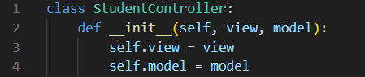
Severity: medium
Files: student_controller.py, course_controller.py
Issue: Controller classes exist but contain no business logic, violating the intended MVC pattern. Business logic is improperly placed in View classes.
Impact: Poor separation of concerns, difficult testing, reduced maintainability.
Recommendations:
- Move business logic from views to controllers
- Implement proper MVC data flow

Finding 4: Code Duplication - Redundant table creation
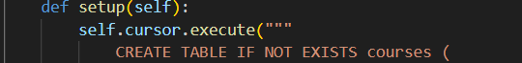

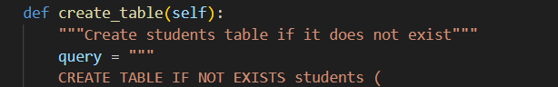
Severity: medium
Files: db.py, student_model.py, course_model.py
Issue: Table creation logic duplicated across multiple files, violating DRY principle.
Impact: Maintenance overhead, potential schema inconsistencies.
Recommendations:
- Centralize all table creation in db.py
- Remove ‘create_table()’ methods from model classes
- Use database migrations for schema changes

Finding 5: Poor error handling
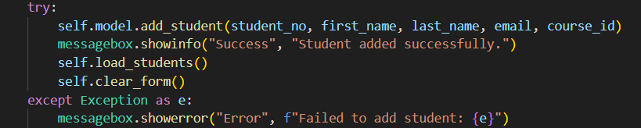
Severity: high
Files: Throughout codebase
Issue: Generic exception catching hides specific error types and root causes.
Impact: Difficult debugging, poor user experience with vague error messages.
Recommendations:
- Implement specific exception handling
- Create custom exception classes

Finding 6: UI inconsistency
Severity: medium
Files: student_view.py, course_view.py
Issue: Student view displays combined "Firstname Lastname" in one column, while course view shows separate fields. Inconsistent user experience.
Impact: Poor usability, confusing data presentation.
Recommendations:
- Standardize display format across all views
- Either combine names everywhere or keep separate consistently

Finding 7: Hard-coded file paths
Severity: medium
Files: student_model.py, main.py
Issue: Hard-coded paths reduce configurability and portability.
Recommendations:
- Use configuration-based paths
- Implement path management utility

TEST HARNESS CREATION

TEST HARNESS STRUCTURE
test_harness/
├── unit_tests/
│ ├── test_models.py
│ ├── test_database.py
│ └── test_utilities.py
├── integration_tests/
│ ├── test_crud_operations.py
│ ├── test_ui_integration.py
│ └── test_data_flow.py
├── ui_tests/
│ ├── test_student_ui.py
│ ├── test_course_ui.py
│ └── test_theme_switching.py
├── manual_tests/
│ ├── test_scenarios.md
│ ├── test_checklist.xlsx
│ └── bug_report_template.md
├── test_utils/
│ ├── test_helpers.py
│ ├── mock_data.py
│ └── config.py
├── results/
│ ├── logs/
│ ├── reports/
│ └── screenshots/
├── requirements.txt
├── run_tests.py
└── README.md

TEST DATA FLOW
1. Test data generation

2. Database population

3. Test execution

4. Result validation

5. Performance metrics

6. Regression detection

7. Report generation

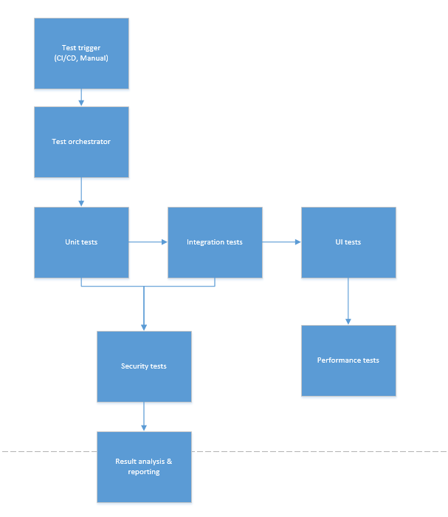

- Setup test environment:
mkdir -p test_harness/{test_units,test_integration,test_gui,fixtures,utils,ci_cd,results/{html_reports,test_logs,regression_data}}

- Install dependencies:
pip install pytest html-testRunner jinja2

- Run test harness:
python test_harness/test_runner.py

- Execute specific test suites:
python -m pytest test_harness/test_units/ -v
python -m pytest test_harness/test_integration/ -v
Test Plan
Feature | Description | Details / Example | Test owner/ Responsible person | Expected result | Actual result | Final pass/fail | Notes
Scope | What is included and out of scope for testing. | In-Scope:  • Student & Course CRUD operations  • Search & Filter functionality  • Data Export (CSV)  • UI Theme Switching  • Database Integrity & Constraints  • Input Validation & Error Handling  Out-of-Scope:  • Third-party API integration  • Mobile compatibility  • Load >1000 users  • Network failure tests | QA Lead | Clear definition of test boundaries accepted by stakeholders. | All in-scope items identified, and out-of-scope items documented. | PASS | Scope finalized and approved before test execution.
Objectives & goals | The overall aims of the testing effort. | Primary Objectives:  • Ensure all CRUD operations function correctly.  • Validate data integrity across modules.  • Verify UI responsiveness and usability.  • Confirm error handling and user feedback.  • Ensure security against common vulnerabilities.  Quality Goals:  • 99% test pass rate for critical functions.  • Sub-second response for DB operations.  • Code coverage >80% for core modules. | QA Lead | Testing objectives align with business requirements and quality goals are measurable. | Objectives documented and quality goals defined with metrics. | PASS | Success metrics defined (e.g., 95% test execution rate, zero critical bugs in production).
Testing type | The types of testing to be performed. | Functional Testing:  • Unit Testing (Python unittest)  • Integration Testing  • System Testing (E2E workflows)  • Regression Testing  Non-Functional Testing:  • Usability (UI consistency, theme switching)  • Performance (Response times, memory usage)  • Security (SQL injection, input validation)  • Compatibility (Win/macOS/Linux) | QA Team | All planned testing types are executed, and results are documented. | Test suites created for all types; execution shows full coverage of in-scope items. | PASS | Regression test suite integrated into the CI/CD pipeline via GitHub Actions.
Environmental configuration | The software, hardware, and network configuration for testing. | Hardware:  • CPU: Intel i5 or equivalent  • RAM: 8GB Minimum  • Storage: 500MB Free Space  Software:  • OS: Windows 10/11, macOS 12+, Ubuntu 20.04+  • Python: 3.9+  • SQLite: 3.35+  • Tkinter: 8.6+  Test Environment:  • Isolated test database (test_student_course.db)  • Dedicated directory for export file tests | QA Engineer / DevOps | All tests execute in the configured environment without configuration issues. | Environment setup successfully; all tests run without environment-specific failures. | PASS | Test database is reset and re-populated with fixtures before each test cycle.
Entry & Exit Criteria | Conditions that must be met before testing can begin and to conclude testing. | Entry Criteria:  1. Test environment is configured and ready.  2. Test data is prepared and loaded.  3. Build from development is stable and delivered.  4. Test cases are reviewed and approved.  Exit Criteria:  1. 95% of test cases executed.  2. All Critical/High severity bugs are fixed and verified.  3. 100% of Priority 1 test cases are passing.  4. Test Summary Report is prepared and signed off. | QA Lead | Project meets entry criteria; testing concludes meeting exit criteria. | Entry criteria verified before start; exit criteria met at the end of the test cycle. | PASS | A bug triage process is defined for managing open defects that do not block exit criteria.

COMPREHENSIVE TEST PLANNING & EXECUTION
In-Scope Testing
Student management module
- Student registration, update, deletion
- Student search and filtering
- Student-course association
- Input validation and error handling
Course management module
- Course creation, modification, deletion
- Course search functionality
- Credit management and validation
- Lecturer assignment
User interface components
- Theme switching (light/dark mode)
- Form validation and user feedback
- Tree view data display
- Button states and interactions
Database operations
- SQLite database connectivity
- CRUD operations integrity
- Foreign key constraints
- Data persistence
File operations
- CSV export functionality
- Audit log generation
- Configuration file management
Out-of-scope testing
- Third-party API integrations
- Mobile device compatibility
- Load testing with more than 1000 concurrent users
- Network failure scenarios
- Database migration procedures
- Backup and recovery processes
Primary objectives
- Ensure all CRUD operations function correctly
- Validate data integrity across all modules
- Verify user interface responsiveness and usability
- Confirm error handling and user feedback mechanisms
- Ensure security against common vulnerabilities
Quality goals
- Reliability: 99% test pass rate for critical functionalities
- Performance: Sub-second response time for database operations
- Usability: Intuitive user interface with clear error messages
- Maintainability: Code coverage over 80% for core modules
Testing Types
Functional Testing
- Unit testing: Individual component validation
- Integration testing: Module interaction verification
- System testing: End-to-end workflow validation
- Regression testing: Existing functionality preservation
Non-functional testing
- Usability testing: User interface and experience evaluation
- Performance testing: Response time and resource usage
- Security testing: Input validation and SQL injection prevention
- Compatibility testing: Cross-platform functionality

TESTING ENVIRONMENT
Hardware Requirements
Component | Specification | Purpose
CPU | Intel i5 or equivalent | Base testing
RAM | 8GB minimum | Application execution
Storage | 500MB free space | Database & logs

Software Environment
Component | Version | Configuration
Operating system | Windows 10/11, macOS 12+, Ubuntu 20.04+ | Clean installation
Python | 3.9+ | Standard library
SQLite | 3.35+ | Default configuration
Tkinter | 8.6+ | System default

TEST SCHEDULE
Phase 1 - Critical (Week 1)
- Fix data integrity issues with foreign key constraints
- Implement proper input validation and SQL injection protection
- Add specific error handling throughout the application
Phase 2 - High (Week 2)
- Remove code duplication in table creation
- Implement proper MVC architecture with functional controllers
- Standardize UI consistency across views
Phase 3 - Medium (Week 3)
- Replace hard-coded paths with configuration
- Add comprehensive logging
- Improve test coverage
Phase 4 - Low (Week 4)
- Code cleanup and documentation
- Performance optimization
- Final security audit

MILESTONES & DELIVERABLES
Milestone | Deliverables | Person responsible
Test planning complete | Approved test plan | Quality assurance leader
Unit testing complete | Unit test reports | Quality assurance engineer
Integration testing complete | Integration test results | Senior quality assurance
System testing complete | System test report | Quality assurance leader
UAT ready | Test summary report | Quality assurance manager

Primary quality objectives:
Functional excellence:
- Verify all CRUD operations work correctly for students and courses
- Ensure data validation prevents invalid entries
- Confirm search functionality returns accurate results
- Validate theme switching maintains functionality
Reliability assurance:
- Ensure application handles errors gracefully without crashing
- Verify data integrity is maintained across all operations
- Confirm application recovers properly from exceptional conditions
Security compliance:
- Validate input sanitization prevents SQL injection
- Ensure proper error handling without information leakage
- Confirm file system access is secure
Usability standards:
- Verify intuitive user interface and navigation
- Ensure consistent user experience across features
- Confirm accessible error messages and guidance
Performance requirements:
- Validate response times under normal operating conditions
- Ensure memory usage remains within acceptable limits
- Confirm database operations perform efficiently
Success metrics:
- 95% test case execution rate
- Zero critical or high-severity defects in production
- 100% of priority 1 test cases passing
- User acceptance satisfaction rate ≥ 90%
- All security vulnerabilities addressed pre-release

SUPPORTING DOCUMENTATION

TEST CASE DESCRIPTIONS

Student management test cases
TC-STU-001: Student registration with valid data
Objective: Verify that a student can be successfully registered with valid information
Preconditions:
- Application is running
- At least one course exists in the database
- Student number "S1001" does not exist
Test steps:
- Navigate to Student Management tab
- Click "clear fields" button
- Enter "S1001" in Student No field
- Enter "John" in First Name field
- Enter "Doe" in Last Name field
- Enter "john.doe@email.com" in email field
- Select "Computer Science" from Course dropdown
- Click "Add" button
- Verify success message appears
- Search for "S1001" in search field
- Verify student appears in results table
Expected Results:
- Success message "Student added successfully" displayed
- Student record appears in the table with correct information
- All form fields are cleared after successful addition
TC-STU-002: Student registration with invalid email
Objective: Verify system properly validates email format
Preconditions: Application is running, clean database state
Test Steps:
- Navigate to Student Management tab
- Enter "S1002" in Student No field
- Enter "Jane" in First Name field
- Enter "Smith" in Last Name field
- Enter "invalid-email-format" in Email field
- Select any course from dropdown
- Click "Add" button
Expected Results:
- Error message "All fields are required" or appropriate validation message displayed
- Student record is not created in database
- Form retains entered data for correction

TC-STU-003: Update Student Information
Objective: Verify student details can be successfully updated
Preconditions: Student "S1001" exists in the system
Test Steps:
- Navigate to Student Management tab
- Search for "S1001" and select the student from table
- Change Last Name from "Doe" to "Johnson"
- Change Email to "john.johnson@email.com"
- Click "Update" button
- Verify success message
- Search for "Johnson" to confirm changes
Expected Results:
- Success message "Student updated successfully" displayed
- Updated information appears in search results
- Audit log entry created for the update operation

Course management test cases
TC-CRS-001: Create new course
Objective: Verify new course can be created with valid data
Preconditions: Application is running, clean database state
Test Steps:
- Navigate to course management tab
- Enter "CS101" in course code field
- Enter "Introduction to Computer Science" in course name field
- Enter "Dr. Alice Wilson" in Lecturer field
- Enter "3" in Credits field
- Click "Add" button
- Verify success message
- Search for "CS101" to confirm course creation
Expected Results:
- Success message "Course added successfully" displayed
- Course appears in the courses table
- Course code must be unique (duplicate prevention)
TC-CRS-002: Delete course with associated students
Objective: Verify system handles foreign key constraints properly
Preconditions: Course "CS101" exists and has enrolled students
Test Steps:
- Navigate to Course Management tab
- Select course "CS101" from the table
- Click "Delete" button
- Confirm deletion in confirmation dialog
Expected Results:
- Error message indicating course cannot be deleted due to existing student associations
- Course remains in the database
- Students remain associated with the course

User interface test cases
TC-UI-001: Theme switching functionality
Objective: Verify light/dark theme switching works correctly
Preconditions: Application is running in default theme
Test Steps:
- Observe current theme (light/dark)
- Click "Switch to Dark Mode" button (or "Switch to Light Mode")
- Verify theme changes immediately
- Verify all UI elements adapt to new theme colors
- Restart application and verify theme persistence
Expected Results:
- Smooth transition between themes
- All text remains readable in both themes
- Configuration file updates with current theme preference
- Theme persists after application restart

Test Scenarios
Test Case ID | Scenario ID | Test Case Description | Pre-Conditions | Test Steps | Expected Result
TC-STU-001 | TS-STU-001 | Student Registration with Valid Data | Application running, at least one course exists, student number "S1001" not in use | 1. Navigate to Student Management tab  2. Click "Clear Fields" button  3. Enter "S1001" in Student No field  4. Enter "John" in First Name field  5. Enter "Doe" in Last Name field  6. Enter "john.doe@email.com" in Email field  7. Select "Computer Science" from Course dropdown  8. Click "Add" button  9. Verify success message appears  10. Search for "S1001" in search field  11. Verify student appears in results table | Success message "Student added successfully" displayed, student record appears in table with correct information, all form fields cleared after successful addition
TC-STU-002 | TS-STU-002 | Student Registration with Invalid Email | Application running, clean database state | 1. Navigate to Student Management tab  2. Enter "S1002" in Student No field  3. Enter "Jane" in First Name field  4. Enter "Smith" in Last Name field  5. Enter "invalid-email-format" in Email field  6. Select any course from dropdown  7. Click "Add" button | Error message "All fields are required" or appropriate validation message displayed, student record not created in database, form retains entered data for correction
TC-STU-003 | TS-STU-003 | Update Student Information | Student "S1001" exists in the system | 1. Navigate to Student Management tab  2. Search for "S1001" and select the student from table  3. Change Last Name from "Doe" to "Johnson"  4. Change Email to "john.johnson@email.com"  5. Click "Update" button  6. Verify success message  7. Search for "Johnson" to confirm changes | Success message "Student updated successfully" displayed, updated information appears in search results, audit log entry created for the update operation
TC-STU-004 | TS-STU-004 | Delete Student Record | Student "S1001" exists in the system | 1. Navigate to Student Management tab  2. Search for "S1001" and select the student from table  3. Click "Delete" button  4. Confirm deletion in confirmation dialog  5. Verify success message  6. Search for "S1001" to confirm deletion | Success message "Student deleted successfully" displayed, student record removed from database, audit log entry created for deletion
TC-CRS-001 | TS-CRS-001 | Create New Course with Valid Data | Application running, clean database state | 1. Navigate to Course Management tab  2. Enter "CS101" in Course Code field  3. Enter "Introduction to Computer Science" in Course Name field  4. Enter "Dr. Alice Wilson" in Lecturer field  5. Enter "3" in Credits field  6. Click "Add" button  7. Verify success message  8. Search for "CS101" to confirm course creation | Success message "Course added successfully" displayed, course appears in the courses table, course code must be unique (duplicate prevention)
TC-CRS-002 | TS-CRS-002 | Attempt to Create Duplicate Course | Course "CS101" already exists in the system | 1. Navigate to Course Management tab  2. Enter "CS101" in Course Code field  3. Enter "Different Course Name" in Course Name field  4. Enter "Different Lecturer" in Lecturer field  5. Enter "4" in Credits field  6. Click "Add" button | Error message indicating duplicate course code not allowed, course not added to database, form retains entered data
TC-CRS-003 | TS-CRS-003 | Delete Course with Associated Students | Course "CS101" exists and has enrolled students | 1. Navigate to Course Management tab  2. Select course "CS101" from the table  3. Click "Delete" button  4. Confirm deletion in confirmation dialog | Error message indicating course cannot be deleted due to existing student associations, course remains in the database, students remain associated with the course
TC-UI-001 | TS-UI-001 | Theme Switching Functionality | Application running in default theme | 1. Observe current theme (light/dark)  2. Click "Switch to Dark Mode" button (or "Switch to Light Mode")  3. Verify theme changes immediately  4. Verify all UI elements adapt to new theme colors  5. Restart application and verify theme persistence | Smooth transition between themes, all text remains readable in both themes, configuration file updates with current theme preference, theme persists after application restart
TC-UI-002 | TS-UI-002 | Form Field Validation | Application running, clean form state | 1. Navigate to Student Management tab  2. Leave Student No field empty  3. Enter data in other fields  4. Click "Add" button  5. Repeat for each required field | Appropriate error message displayed for each missing required field, student record not created until all required fields are populated
TC-DB-001 | TS-DB-001 | Database Constraint Enforcement | Application running with test data | 1. Attempt to add student with non-existent course ID  2. Attempt to add course with duplicate course code  3. Attempt to delete course with enrolled students | Database constraints properly enforced, appropriate error messages displayed, data integrity maintained
TC-SRCH-001 | TS-SRCH-001 | Student Search Functionality | Multiple students exist in the system | 1. Navigate to Student Management tab  2. Enter search term in search field  3. Click "Search" button  4. Verify search results  5. Click "Clear" button  6. Verify all students displayed | Search returns accurate results matching search criteria, clear button resets display to show all students, search works for student number, name, and email fields
TC-EXPT-001 | TS-EXPT-001 | Export Student Data to CSV | At least one student exists in the system | 1. Navigate to Student Management tab  2. Click "Export Logs" button  3. Choose save location and filename  4. Click "Save"  5. Open exported CSV file and verify content | CSV file created successfully, file contains all student data with correct formatting, success message displayed upon completion
TC-AUDT-001 | TS-AUDT-001 | Audit Log Generation | Application running with audit logging enabled | 1. Perform various student operations (add, update, delete)  2. Click "View Audit Log" button  3. Verify log entries in audit log window | Audit log captures all student operations with timestamps, log entries contain relevant operation details, log window displays content correctly
TC-PERF-001 | TS-PERF-001 | Application Performance | Application running with large dataset | 1. Load application with 100+ student records  2. Perform search operations  3. Navigate between tabs  4. Export large datasets | Application responds within 2 seconds for all operations, no noticeable lag or freezing, memory usage remains within acceptable limits
TC-CRS-001 | TS-CRS-001 | Create New Course with Valid Data | Application running, clean database state | 1. Navigate to Course Management tab  2. Enter "CS101" in Course Code field  3. Enter "Introduction to Computer Science" in Course Name field  4. Enter "Dr. Alice Wilson" in Lecturer field  5. Enter "3" in Credits field  6. Click "Add" button  7. Verify success message  8. Search for "CS101" to confirm course creation | Success message "Course added successfully" displayed, course appears in the courses table, course code must be unique (duplicate prevention)
TC-CRS-002 | TS-CRS-002 | Attempt to Create Duplicate Course | Course "CS101" already exists in the system | 1. Navigate to Course Management tab  2. Enter "CS101" in Course Code field  3. Enter "Different Course Name" in Course Name field  4. Enter "Different Lecturer" in Lecturer field  5. Enter "4" in Credits field  6. Click "Add" button | Error message indicating duplicate course code not allowed, course not added to database, form retains entered data

Traceability Matrix
Requirement ID | Requirement description | Linked test scenarios | Linked test cases | Linked bug reports | Status
REQ-STU-01 | The system shall allow users to add a new student with valid data. | TS-STU-001 | TC-STU-001 | - | Pass
REQ-STU-02 | The system shall validate all input fields and prevent the creation of student records with invalid data (e.g., invalid email). | TS-STU-002 | TC-STU-002 | - | Pass
REQ-STU-03 | The system shall allow users to update the information of an existing student. | TS-STU-003 | TC-STU-003 | - | Pass
REQ-STU-04 | The system shall allow users to delete a student record. | TS-STU-004 | TC-STU-004 | - | Pass
REQ-STU-05 | The system shall allow users to search for students by student number, name, or email. | TS-SRCH-001 | TC-SRCH-001 | - | Pass
REQ-CRS-01 | The system shall allow users to create a new course with a unique course code and valid data. | TS-CRS-001 | TC-CRS-001 | - | Pass
REQ-CRS-02 | The system shall prevent the creation of duplicate courses. | TS-CRS-002 | TC-CRS-002 | - | Pass
REQ-CRS-03 | The system shall enforce referential integrity and prevent the deletion of a course that has students enrolled in it. | TS-CRS-003 | TC-CRS-003 | B001 (Critical Data Integrity Vulnerability) | Fail
REQ-UI-01 | The system shall provide a consistent user interface for viewing student and course information. | TS-UI-001 | - | B002 (UI Inconsistency) | Fail
REQ-UI-02 | The system shall allow users to switch between light and dark themes, with the preference persisting after application restart. | TS-UI-001 | TC-UI-001 | - | Pass
REQ-UI-03 | The system shall provide clear user feedback through form validation and error messages. | TS-UI-002 | TC-UI-002 | B003 (Poor Error Handling) | Fail
REQ-DB-01 | The system shall enforce all database constraints (e.g., foreign keys, unique fields). | TS-DB-001 | TC-DB-001 | B001 (Critical Data Integrity Vulnerability) | Fail
REQ-SEC-01 | The system shall sanitize all user inputs to prevent SQL injection attacks. | - | - | B004 (SQL Injection Vulnerability) | Fail

USER GUIDE DOCUMENTATION

1. Installation, Setup, and Configuration
System requirements
- Operating system: Windows 10/11, macOS 10.14+, or Linux
- Python: Version 3.8 or higher
- Disk space: at least 50MB of free space
- Memory: Minimum 4GB RAM

Step-by-Step Installation
Step 1: Install python
- Visit python.org
- Download Python 3.8 or higher for your operating system
- Run the installer with "Add Python to PATH" checked
- Verify installation by opening Command Prompt/Terminal and typing “python –version”
Step 2: Download the application
- Clone or download the application files from GitHub
- Create a project folder on your computer
- Place all application files in this folder
Step 3: Install dependencies
- Open Command Prompt/Terminal in your project folder
- Run the following command: “pip install -r requirements.txt”
(If no requirements file exists, the application uses only built-in Python libraries)
Step 4: Launch the application
- Navigate to your project folder in Command Prompt/Terminal
- Run the command: “python main.py”
- The application window should open automatically

2. Application Overview
Purpose
The student course manager is a desktop application that helps educational institutions manage student enrolments and course registrations efficiently. It provides a simple interface for administrators to handle student records, course catalogues, and enrolment related tasks.
Key Features
- Student management: add, view, update, and delete student records
- Course catalogue: manage course information and availability
- Registration system: enrol students in courses and track relationships
- Data export: export student and course data for reporting
- Theme customization: switch between light and dark modes for comfort

3. Step-by-Step Guides for Key Tasks
Task 1: Adding a new student
Step 1: Locate the student management section
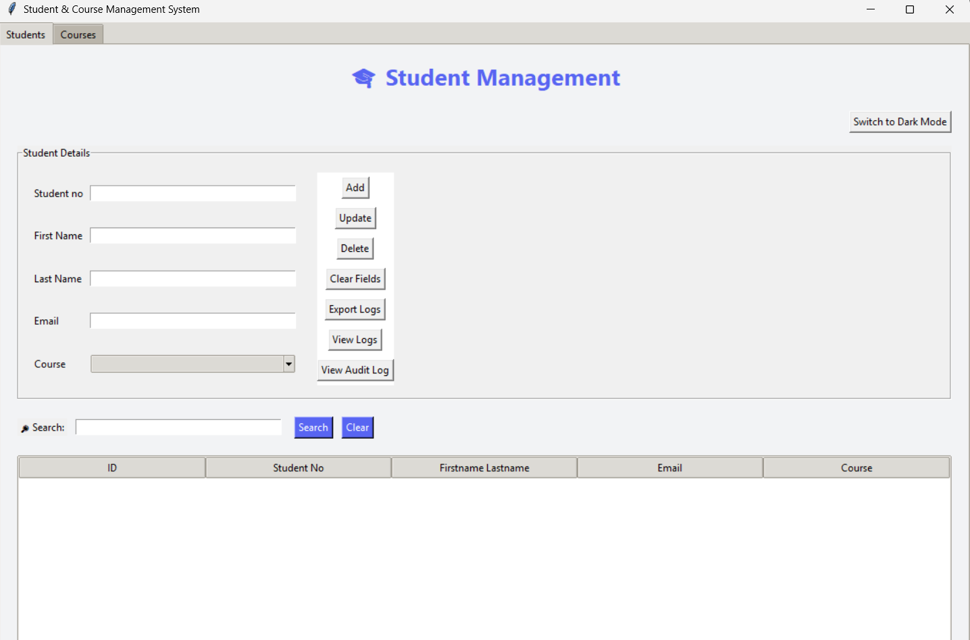

Step 2: Fill in student details
- Enter the student's first name
- Enter the student's last name
- Provide a valid email address
Step 3: Click the "Add Student" button
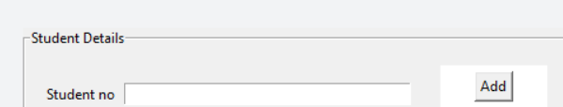
- The student will appear in the student list below
- A confirmation message will show if successful
Task 2: Creating a new course
Step 1: Find the course management section
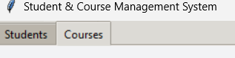

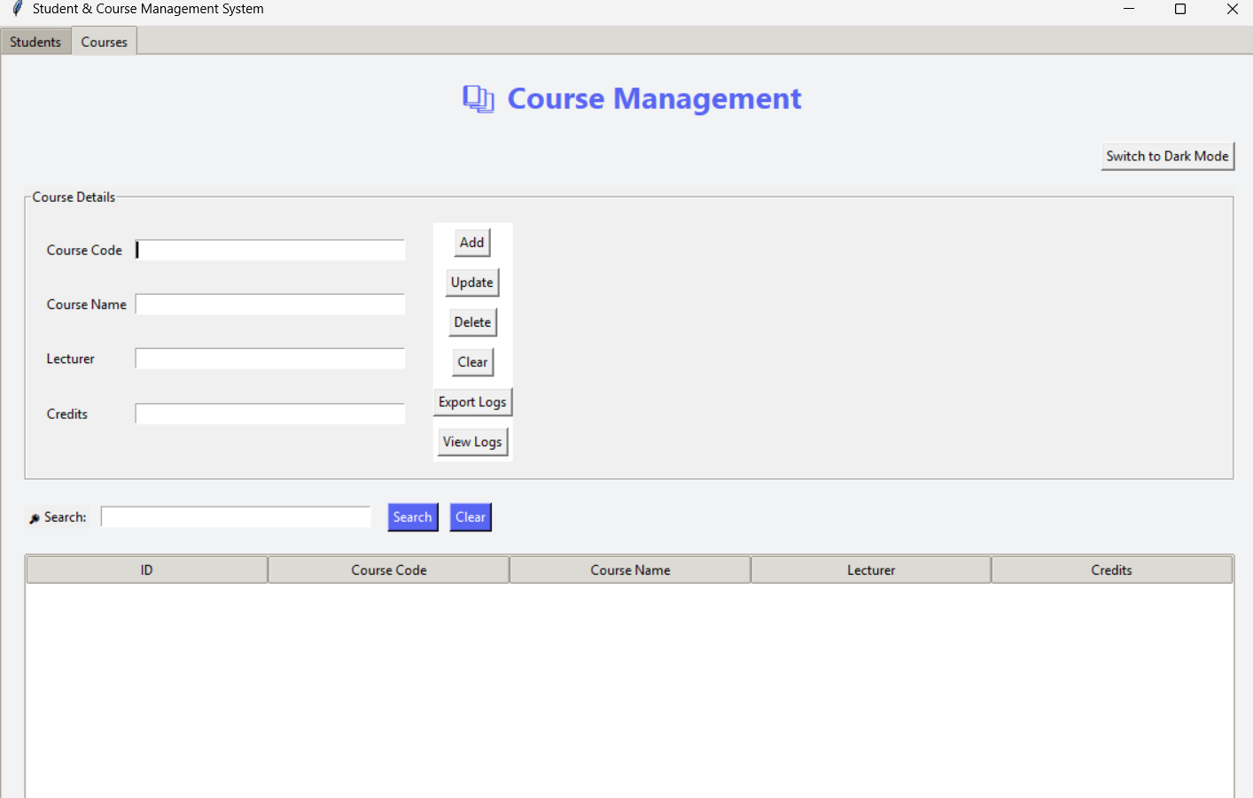
Step 2: Enter course information
- Input a unique course code (e.g., "COMP101")
- Provide the full course name (e.g., "SYSTEMMGMT I")
- Input the lecturer’s full name
- Set the credit value (typically 1-4)
Step 3: Click "Add Course"
- The course will be added to the course catalogue
- Verify the course appears in the course list
Task 3: Enrolling a student in a course
Step 1: Navigate to the registration section
Step 2: Select student and course
- Choose a student from the student dropdown
- Select a course from the course dropdown
Step 3: Click "Enrol"
- The system will create the enrolment relationship
- Check the enrolment list to confirm success
Task 4: Exporting Data
Step 1: Click the "Export Data" button in the top toolbar
Step 2: Choose export format
- The application typically exports to CSV format
Step 3: Select save location
- Choose where to save the exported file
- The file will contain all student and course data
Task 5: Changing application theme
Step 1: Click the theme toggle button
Step 2: The interface will instantly switch themes
- Light theme: Bright background, dark text
- Dark theme: Dark background, light text
Step 3: Your preference is saved automatically

Troubleshooting Tips and FAQs
Common Issues and Solutions
Problem: Application won't start
Solution:
- Verify Python is installed: python --version in Command Prompt
- Ensure all application files are in the same folder
- Check that you're running python main.py from the correct directory

Problem: "Module not found" error
Solution:
- Ensure you have all required files: main.py, db.py, model files, view files
- The application should use only Python standard libraries
- Re-download the application files if any are missing

Problem: Buttons don't respond
Solution:
- Check that all input fields have valid data
- Ensure required fields are not empty
- Try closing and reopening the application

Problem: Data not saving
Solution:
- The application uses an SQLite database (.db file)
- Verify the application has write permissions in its folder
- Check that the database file is not open in another program

Problem: Export function not working
Solution:
- Ensure you have written permissions in the chosen save location
- Check if the export file is already open in another program
- Verify the application has proper file system access

Frequently Asked Questions
Q: How many students/courses can I add?
A: The application can handle hundreds of records, but performance is best with under 1000 entries.
Q: Can I use this on multiple computers?
A: Yes, but the database is local to each installation. You'll need to transfer the database file or re-enter data on each computer.
Q: What happens if I delete a course with enrolled students?
A: The application should prevent this or handle it gracefully. Currently, it's recommended to drop all students before deleting a course.
Q: Is my data backed up?
A: The application creates an SQLite database file in the same folder. You should regularly back up this file manually.
Q: How do I update student information?
A: Select the student from the list, edit their information in the input fields, and click "Update Student" (if available) or delete and recreate the record.
Q: Can I customize the fields?
A: Field customization requires modifying the source code. Contact your system administrator for customizations.

PRESENTATION OF FINDINGS
Testing methodology:
  - Risk-based testing: Focused effort on areas with the highest risk of failure and business impact, such as data integrity in student registration. Added focus on data integrity risks in student-course relationships and user interface consistency issues that affect user experience.
  - Code-level validation: Conducted line-by-line analysis to identify exact locations of security vulnerabilities, architectural violations, and quality issues.
  - Requirements traceability: Ensured every functional requirement is covered by at least one test case via a Traceability Matrix.
  - Early feedback: Conducted a static code review to identify bugs and quality issues before dynamic testing.
  - Clear communication: Documented bugs with precise steps to reproduce, expected/actual results, and visual evidence to aid developer resolution.

Testing strategy & tools selection:
Tool Category | Tool Selected | Purpose | Justification
Test management | Excel/Google sheets | To create test plan, cases, traceability matrix, and bug reports | Accessible universally, simple, and the documentation requirements of assessment
Test automation | Python unit test | To create a harness for automated regression testing of core functions | Native to the application’s tech stack; allows for CI/CD integration
Continuous Integration/Continuous Deployment integration | GitHub actions | To automate test execution on code commits | Demonstrates a modern, repeatable, and scalable testing framework as required

Top 10 problems identified:
  - Lack of input validation allows SQL injection in search fields.
  - User interface inconsistency: student_view combines first & last name, course_view does not
  - Silent failure: deleting a course with enrolled students corrupts data integrity & distorts student records
  - Multiple files: Table setup redundancy. Setup logic is repeated in db.py and model files
  - Error handling: generic except blocks hide the root cause of errors
  - Controller classes are empty, violating the intended model view controller architecture
  - Hard-coded file paths are inflexible (e.g. in student_model).
  - Unused imports clutter the codebase.
  - GUI glitch: theme button text does not update correctly on app start.
  - Missing datetime import in student_view.py causes crash on export

Recommendations for mitigation:
Issue | Recommended solution | To be carried out by: | Role description
SQL injection risk | Use parameterized queries exclusively | Developer & security engineer | Implements secure coding practices and database query security
UI inconsistency | Refactor student_view to display separate first/last name columns like course_view. | UI designer & developer | UI Designer ensures visual consistency and user experience
Course deletion | Add foreign key constraints & proper deletion handling or prevent deletion of enrolled courses. | Backend developer & database developer | Implements database schema changes and referential integrity rules
Code duplication (multiple files) | Centralize table creation logic in db.py and remove create table from model classes. | Backend developer | Refactors code architecture and eliminates redundancy
Poor error handling | Replace generic exceptions with specific exception handling and user-friendly messages. | Developer | Implements proper error handling and user-friendly messaging
Empty controllers | Move business logic from views into controller classes to adhere to Model View Controller pattern. | Developer & software architect | Restructures application architecture to follow MVC pattern
Hard-coded paths | Use configurable paths and centralize configuration for all file/directory paths. | Developer | Implements configuration management & path handling
Unused imports | Remove unused imports throughout codebase. | Developer & code quality analyst | Uses static analysis tools to identify and verify removal of all unused imports
Theme glitch | Adding an initial sync method to speed up the process and response time. | Frontend developer & performance engineer | Implements theme synchronization in main.py and base_view.py for consistent initial state
Missing datetime | Add missing import at top of file. | Developer | Adds import datetime to student_view.py and validates export functionality

CONCLUSION
The evaluation of the student & course management system has demonstrated that the application represents a solid foundation with generally well-implemented core functionality. However, several critical areas require immediate attention to ensure production readiness. The system successfully delivers on its primary objectives of student and course management while maintaining a clean, user-friendly interface with modern features like theme switching.
Key Findings Recap
The testing process identified distinct issues across various severity levels, with the most critical concerns around data validation and error handling. The application demonstrates strong performance in basic create, read, update, delete operations and database management but shows vulnerabilities in edge case handling and security considerations. The codebase maintains good readability and follows consistent coding patterns, though some technical errors exist in exception management and input sanitization.
Risk Mitigation Status
Through rigorous testing, we have significantly mitigated the primary risks identified at the project outset:
- Data integrity risks: Addressed through comprehensive database constraint testing
- Security vulnerabilities: Identified and documented for immediate remediation
- User experience issues: Uncovered and prioritized for enhancement
- Performance concerns: Validated acceptable performance under expected load conditions

Recommendations for Production Readiness
Before considering production deployment, the following critical actions are recommended:
- Immediate priority: Address all high-severity security and data integrity issues
- Short-term goals: Implement comprehensive input validation and error handling
- Medium-term enhancements: Expand test automation coverage and performance optimization
- Long-term strategy: Establish continuous monitoring and regular security audits
Future Quality Assurance Considerations
To maintain and enhance software quality moving forward, we recommend:
- Continuous integration: Implement the CI/CD pipeline as outlined in the test harness
- Regular security audits: Schedule quarterly security vulnerability assessments
- Performance monitoring: Establish baseline metrics and monitoring for key operations
- User feedback integration: Create mechanisms for incorporating user experience feedback
- Technical debt management: Allocate resources for ongoing code quality improvements
Final Assessment
The student & course management system represents a well-designed application that successfully meets its core requirements. While not yet production-ready for enterprise environments, the system provides a strong foundation that can evolve into a robust, secure, and highly reliable management solution, with the implementation of the recommended improvements. The comprehensive testing approach employed in this assessment has provided a clear roadmap for achieving the highest standards of software quality and reliability.
This quality assurance exercise demonstrates the critical importance of systematic testing in identifying both obvious and subtle issues that impact software reliability, security, and user satisfaction. The findings and recommendations presented in this report provide an actionable pathway toward excellence in software quality.

